**PRAKTIKUM**

**DASAR PEMROGRAMAN**

**SEMESTER GENAP TAHUN AKADEMIK 2024/2025**

**Tanggal**

**.....................................**

**Materi**

**..............................................................................................................**

**PRODI SISTEM INFORMASI FAKULTAS TEKNIK DAN ILMU KOMPUTER**

**UNIVERSITAS NUSANTARA PGRI KEDIRI 2025**

**BAB II**

**PERCOBAAN DAN LATIHAN**

**Percobaan 1**

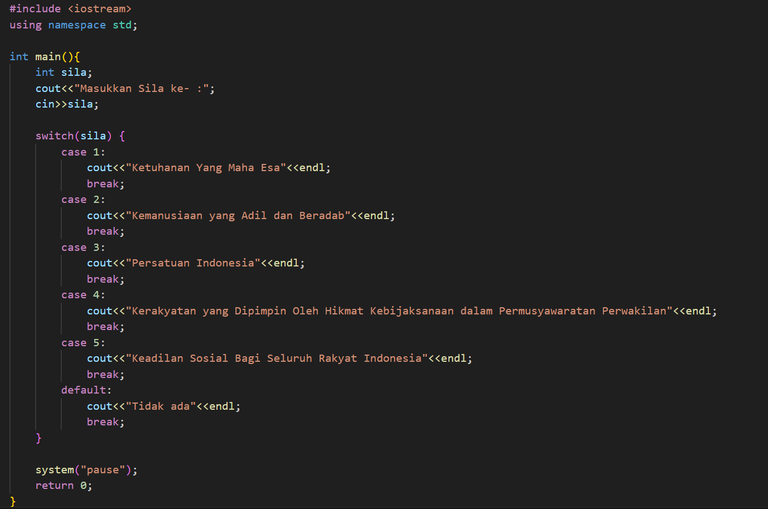

**Latihan 1**

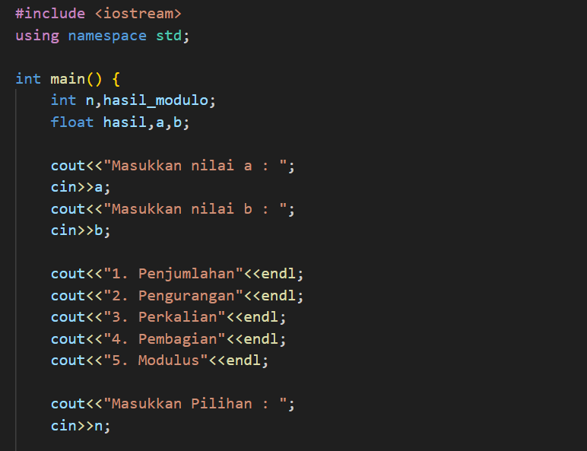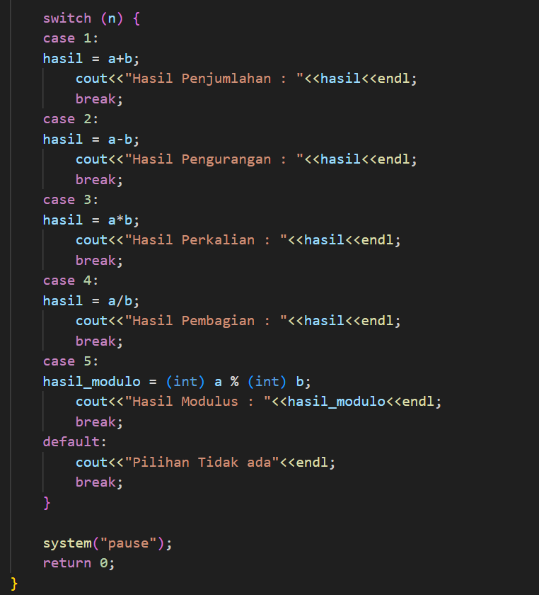

**BAB III**

**TAMPILAN PROGRAM**

**Percobaan 1**

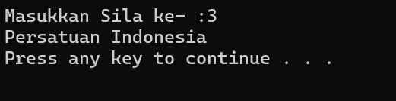

**Latihan 1**

